**Polygon Modeling**

A polygon is an n-sided shape defined by a group of ordered vertices and the edges that are defined by pairs of those vertices. Polygons are made up of several components:

* Vertices
* Edges
* Faces

Modeliing done using these polygons is known as polygon modelling.

Creating a polygon

A polygon can be created in many ways. Two ways are shown below:

Using Create Polygon Tool

* Select Polygons > Create Polygon Tool.
* In any view, click the left mouse button consecutively two make vertices of the polygon
* To complete the new polygon, press Enter.

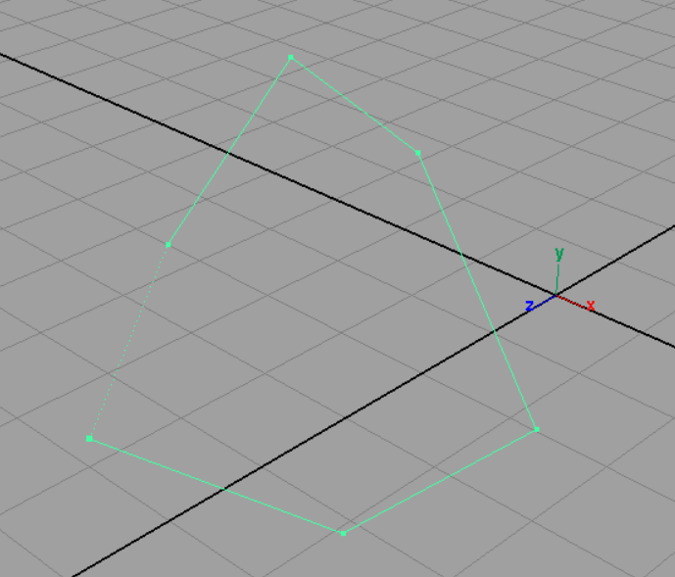 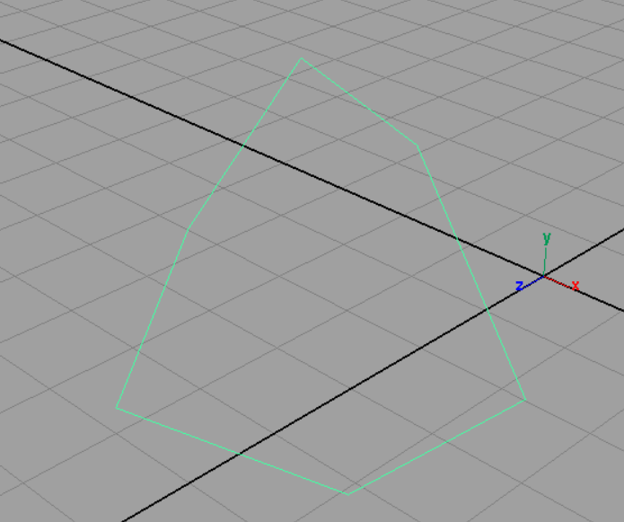

Using Create Option

Goto Create > Polygon primitives

And select the desired polygon

* Sphere

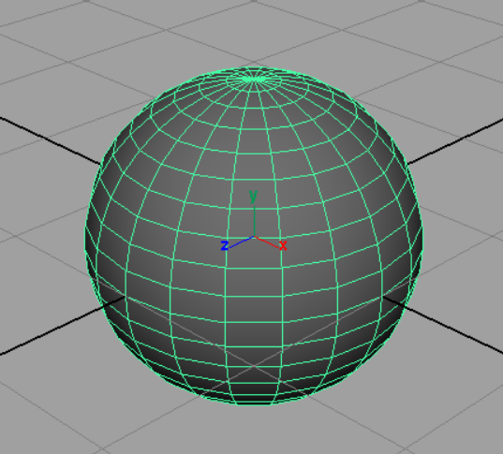

* Cube

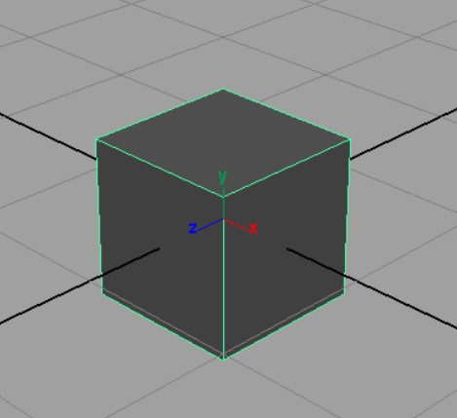

* Cylinder

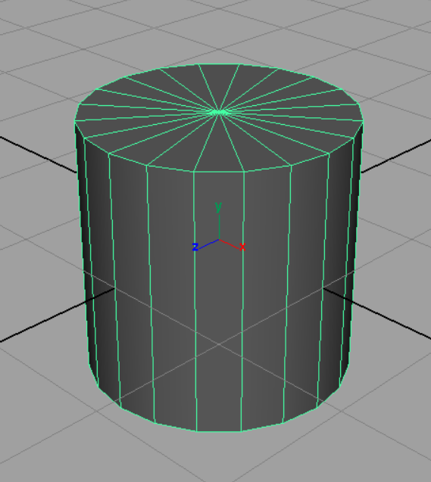

* Cone

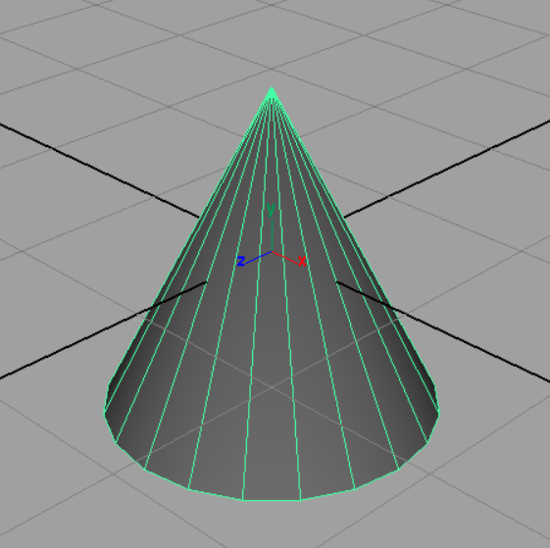

* Plane

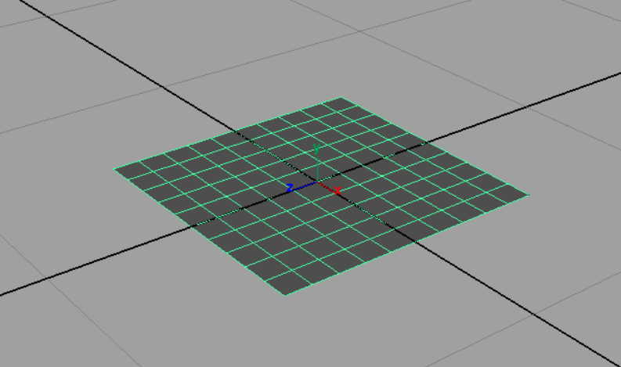

* Torus

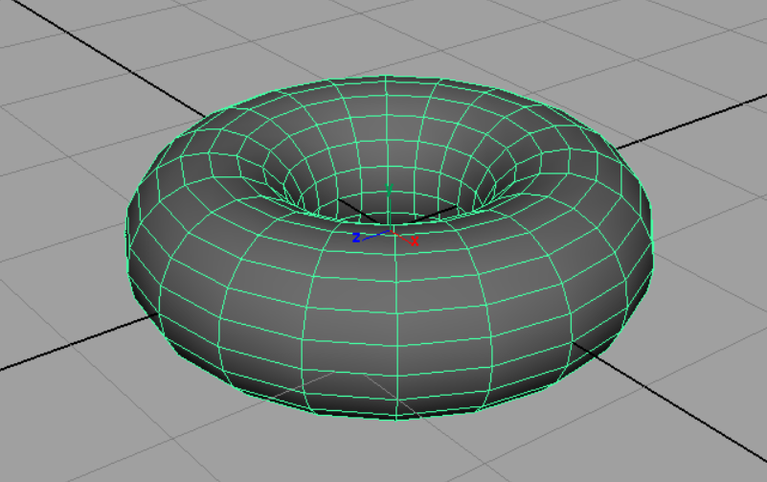

Extrude

Pulling faces and Edges out of a polygonal object is called extruding. There are two options for extruding in maya –

Extruding faces

* Select the face you want to extrude from the polygonal surface

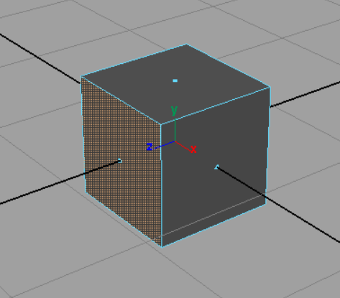

* Goto Edit Polygons > Extrude Face

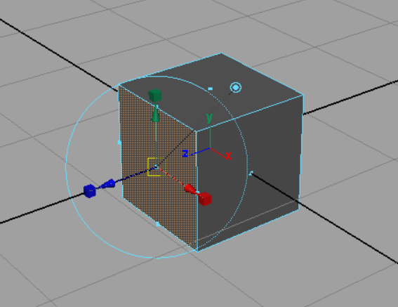

* Now using the move tool extrude the face as much as you want

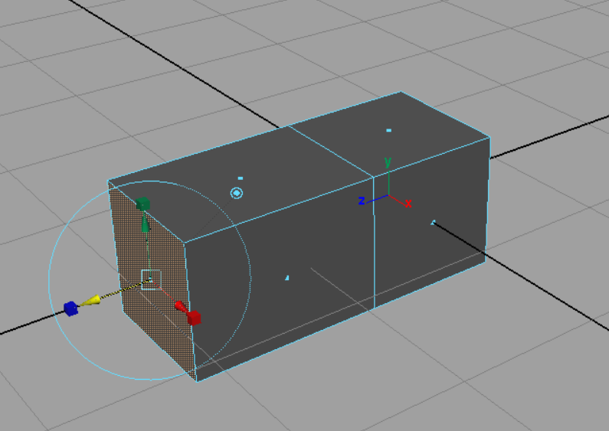

Extruding Edges

* Select the edge you want to extrude from the polygonal surface

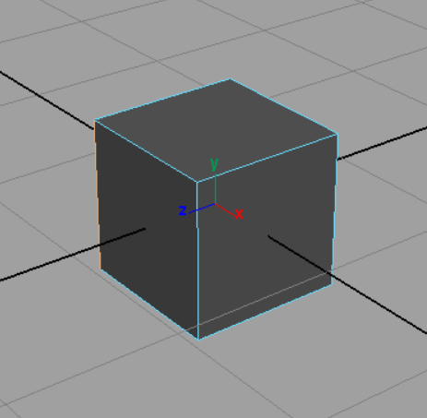

* Goto Edit Polygons > Extrude Edge

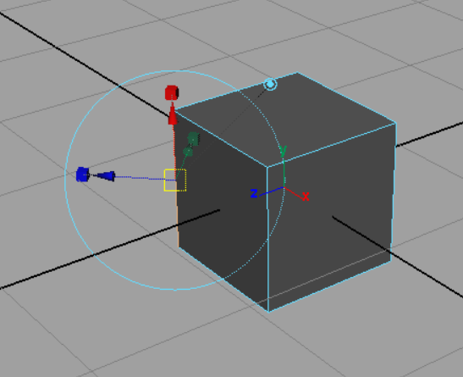

* Now using the move tool extrude the edge as much as you want

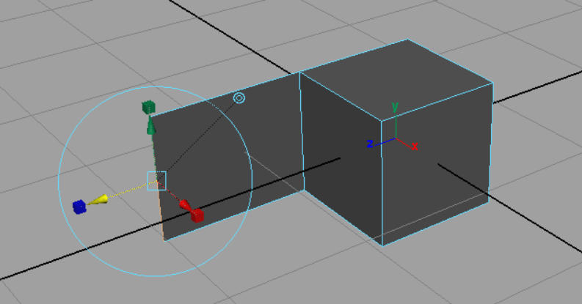

Duplicating faces

We can duplicate faces or even the whole polygons in maya. To duplicate faces -

Select the face that you want to duplicate



Goto Edit polygons > Duplicate face

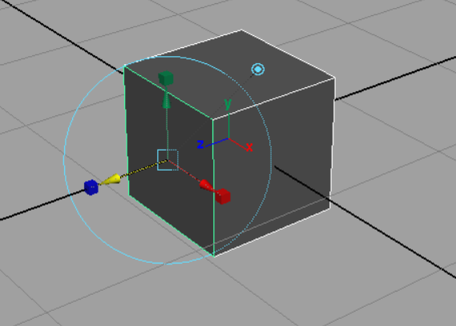

Now use the move tool to move the duplicate face formed

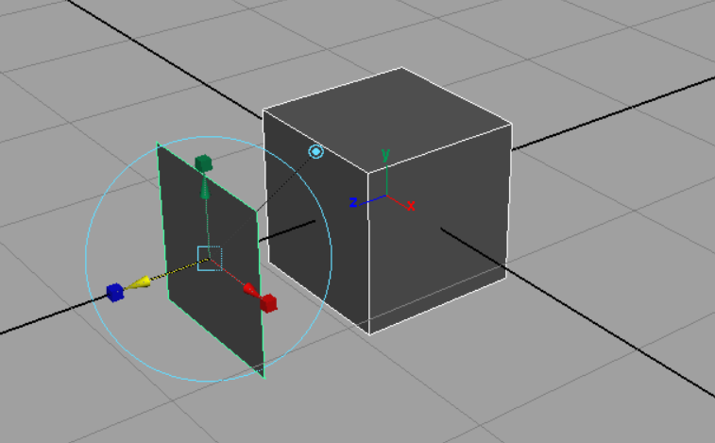

Subdivide

Maya has the option of subdividing a polygon or face –

* Select the polygon/face you want to sub-divide

 

* Goto Edit polygons > Subdivide
* The selected polygon/face has been sub-divided

